Alan Lawrence

Module 2 HW

10/29/2023

* **2018**

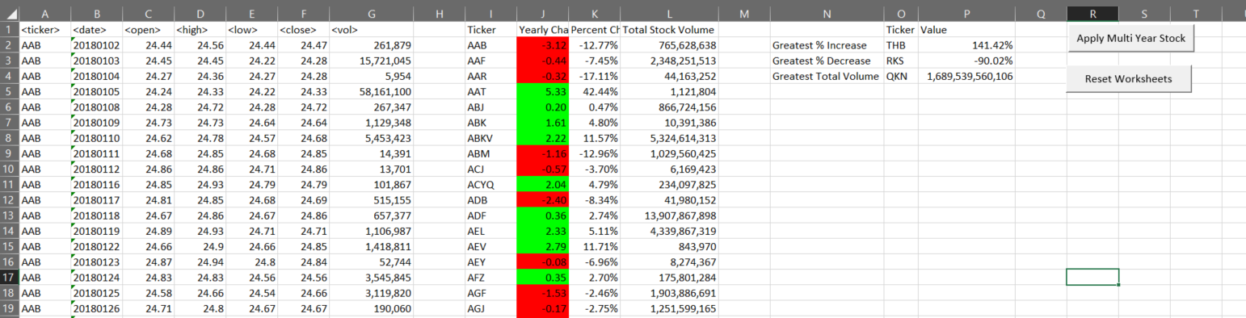

* **2019**

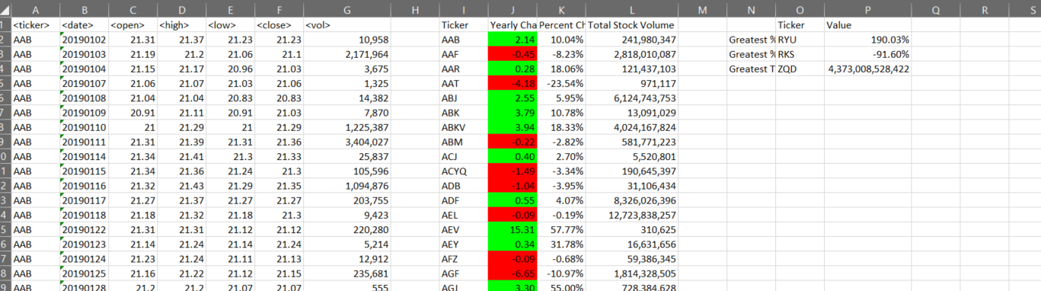

* **2020**

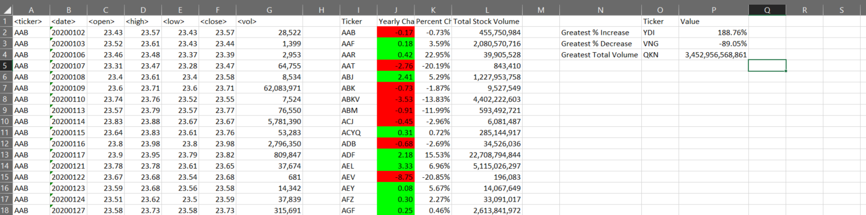

**Code:**

Sub Reset_Worksheets_Button():

Dim ws As Worksheet

For Each ws In ThisWorkbook.Worksheets

' Clear contents in range I:P

ws.Range("I:P").ClearContents

' Clear cell interior color (background color)

ws.Range("I:P").Interior.ColorIndex = xlNone

Next ws

End Sub

Sub All_Stock_WS_Button():

Application.ScreenUpdating = True

For Each ws In Worksheets

ws.Activate

ws.Range("I:Q").EntireColumn.AutoFit

ws.Range("P4").NumberFormat = "#,##0"

ws.Range("G:G").NumberFormat = "#,##0"

ws.Range("L:L").NumberFormat = "#,##0"

Call Stock_WS

Next ws

End Sub

' Create ProcessWS to force variables out of scope between sheets.

Sub Stock_WS():

' Set up headers

Range("I1:L1") = Array("Ticker", "Yearly Change", "Percent Change", "Total Stock Volume")

Range("O1:P1") = Array("Ticker", "Value")

Range("N2:N4") = Application.Transpose(Array("Greatest % Increase", "Greatest % Decrease", "Greatest Total Volume"))

Range("J:J").NumberFormat = "0.00"

Range("K:K, P2:P3").NumberFormat = "0.00%"

' Define variables

Dim ticker As String

Dim open_price, year_changing, percent_update, volume_total As Double

Dim increased_ticker, decreased_ticker, vol_ticker As String

Dim best_increase, best_decrease, best_vol As Double

Dim input_row As Long

Dim output_row As Integer

' Establish initial conditions

ticker = Range("A2")

open_price = Range("C2")

volume_total = Range("G2")

input_row = 3

output_row = 2

While (ticker <> "") ' Loop until there is no more data

While (ticker = Cells(input_row, 1)) ' Loop until arriving at the next ticker symbol

volume_total = volume_total + Cells(input_row, 7)

input_row = input_row + 1

Wend

' Assign results to output cells

year_changing = Cells(input_row - 1, 6) - open_price

percent_update = year_changing / open_price

Cells(output_row, 9) = ticker

Cells(output_row, 10) = year_changing

If (year_changing < 0) Then

Cells(output_row, 10).Interior.Color = vbRed

ElseIf (year_changing > 0) Then

Cells(output_row, 10).Interior.Color = vbGreen

End If

Cells(output_row, 11) = percent_update

If (percent_update < best_decrease) Then

best_decrease = percent_update

decreased_ticker = ticker

ElseIf (percent_update > best_increase) Then

best_increase = percent_update

increased_ticker = ticker

End If

Cells(output_row, 12) = volume_total

If (volume_total > best_vol) Then

best_vol = volume_total

vol_ticker = ticker

End If

ticker = Cells(input_row, 1)

open_price = Cells(input_row, 3)

volume_total = 0

output_row = output_row + 1

Wend

' Assign overall results

Range("O2") = increased_ticker

Range("P2") = best_increase

Range("O3") = decreased_ticker

Range("P3") = best_decrease

Range("O4") = vol_ticker

Range("P4") = best_vol

End Sub